21st Annual WFWP – Europe Women’s Leadership Conference

**Theme: Women leading the Change:**

**Towards Peacebuilding, Justice, and Social Transformation**

Warsaw, Poland, November 8-10, 2024

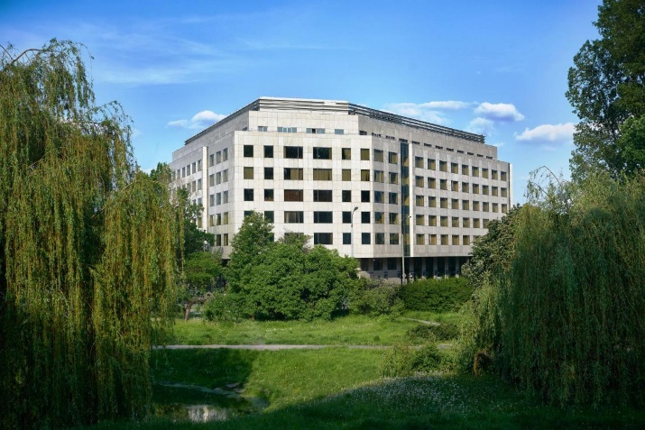 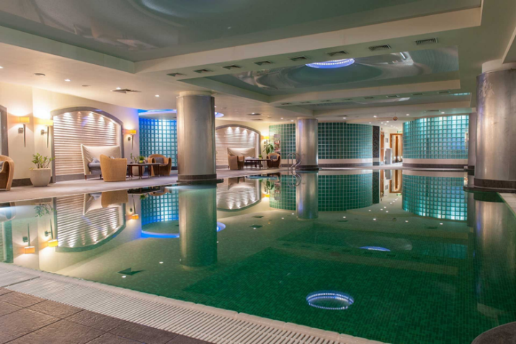

**IMPORTANT INFORMATION FOR PARTICIPANTS**

**Location**: Regent Warsaw Hotel, BELWEDERSKA 23 AV., 00-761 WARSAW, POLAND,

(The Regent Warsaw Hotel boasts a central location right next to Royal Łazienki Park and just moments away from the city’s main tourist and business locations.)

Website: <https://www.regent-warsaw.com/en>

**Contact persons:** Brigitte Wada +33 6 21 54 40 01; Aleksandra Skonieczna +48 501 088 177

**Transport:**

From Warsaw Chopin Airport (WAW): **Warsaw Airport** is only 10km from the city centre and is generally easy to reach by private hire, taxi, train, or bus. The journey takes roughly 30 minutes by any forms of transport. Taxi from Warsaw Airport to City Centre costs around €8,33 - €10,07.

From Warsaw Modlin Airport (WMI) is more than 40km away, about 54 minute drive by car. The fare for a taxi travelling from Warsaw Modlin Airport to the City Centre may range from €29,51 to €38,19.

**Currency**: Despite being a member of the European Union, the national currency of Poland is the Polish zloty (symbol: zł).

**Conference fee:**

**Conference fee twin room:**

**Discount price: 295€** for those who registered early, until the 15th of August

**Regular price: 320€** for those who register after the 15th of August.

**Conference fee single room:**

**Discount price: 355€** until the 15th of August.

**Regular price: 380€** after the 15th of August

**Conference fee includes:**

* Full participation in conference program
* Accommodation for 2 nights in a twin room or single room, including breakfast.
* Full meals from dinner on Friday November 8th, until lunch on Sunday, November 10th. Please note that WFWP will not be providing meals before and after these times.
* 3 Coffee breaks during the conference in the hotel.

For those arriving earlier or leaving later, the cost is 40€/person/night including breakfast in a twin room or 70€ for a single room.

An option of 45 twin rooms (8-10 November) and 10 single rooms have been reserved. If possible,

please register **by 15th of September 2024** so that the exact number of participants can be known to the hotel.

**Note:** This is the policy of the hotel to ask financial guarantee (cash or credit card) from the guests on the day of their arrival in case of damage in the room etc. But at the time of check out guests will be refunded with total amount.

**Payment:**

By Bank Transfer:

IBAN EUR: CH27 0024 3243 5580 1260 H

BIC/Swift Code: UBSWCHZH80A

Account holder:

Women’s Federation for World Peace - Europe

10, Rue Anne-Torcapel, 1202 Genève, Switzerland

Confirmation of your registration will be made after payment. The conference fee payment is non- refundable.

**Registration:**

Registration will take place from 4:00 PM on November 8th. Next to the reception desk there will be a table with the WFWP logo.

At registration, you will receive your name badge, program and other conference materials.

**Note**: The presentations will be in the English language, there will be no translation available.